Outreach and Safety Manual


Table of Contents
Table of Contents 1
Outreach 2
Jail Visits 3
Maslow’s Hierarchy of Needs 4
Light Touch Case Management 5
Intensive Case Management 5
Approaching Campsites 6
Safety 7
Safety Level System 7
Transporting Clients 8
Progressive Engagement 9
Pocket Guide for Motivational Interviewing 10

Outreach
Outreach services are field based services. Outreach workers are embedded in the community, making connections and building relationships. This incredibly important work is designed to help establish supportive relationships and increase participant engagement with supportive services.
We are participant-driven, walking with our clients as they identify and address the underlying cause of homelessness, substance use, mental illness, and troubles within the legal system. Outreach practices persistent engagement, forging a strong rapport with individuals who are service resistant and have a general mistrust of providers.
We create a strong network of relationships with community resources, and coordinate with providers to ensure continuity of care. Outreach can support immediate needs that are key to a person's wellbeing and stabilization. This includes providing and/or coordinating the following: survival services with a focus on access to food, shelter and clothing; housing, to include recovery-based housing, victim services, and housing first models; Medical and behavioral health, to include immediate and ongoing medical care, mental health treatment, and substance use treatment.
While in outreach, we promote self-advocacy, while ensuring our client’s needs are met, and rights are maintained. We continually assess Stage of Change, as defined by the client. We support immediate needs and short-term goals as they relate to stability.
Within this client-in-the-lead framework we practice Harm Reduction, Progressive Engagement and Motivational Interviewing. Outreach utilizes several best-practices when engaging with our clients to help them achieve self-efficacy, and quality outcomes. It begins with assessing the 5 Stages of Change when identifying the appropriate level of engagement between Outreach, Light, and Intensive Case Management.
Outreach provides resources and support associated sustenance and stability. In addition, outreach supports smaller, short term goals, associated with basic physiological needs, safety and security, and a sense of love and belonging.
These goals can have a forward movement, such as accessing treatment services and/or Oxford House. Often times, these goals are fixed around safety and security, such as safe use practices and other life-saving measures.
Clients receiving outreach services often lack the ability to problem-solve, and struggle to access conventional services without assistance, advocacy, and support. Outreach clients are often between pre-contemplation and preparation stage of change.

Jail Visits
When entering the jail, it is important to remember we are guests within a secure facility. Jail visits are a privilege. Below, please find some basic rules and etiquette:
- Always bring your Evergreen Recovery Centers badge and state ID.
- Electronic devices are not allowed inside the jail without prior approval. Always leave cell phones, and personal items in your vehicle. As such, it is important to note resources, full name and proper spelling on your notebook before entering into the facility.
- Always be kind to jail staff. Jail staff work within a locked down facility. Suicide rates among corrections officers are some of the highest among working professionals. Their work is hard. Always show respect, understanding, and patience with jail staff.
- Know the facility. Timeliness is important for both jail staff and our clients. We do not want to interrupt med line, interrupt a meal, or interfere with shift change. Lunch is served between 12:00pm and 1:00pm. Afternoon visits are easiest on staff, with 1:00pm being an optimal time.
- Do not promise things you cannot deliver. Jail outreach is hard. Our folks are often desperate to find a solution. Access and options are limited within the jail. We are not bail bondsmen. It is never appropriate to put money on someone’s books, or assist with bail costs.
- Connections are limited within the jail. Many of our clients ask us to reach out to family or friends, etc. It is of the upmost importance you give due diligence to these requests. Always ask important follow up questions like, “is this person associated with your case?” and “do you have any no contact orders with this person”. Not only do we not want to become a third party, violating a protection order can and will result in additional charges for the participant.
- Visitation booths and phone calls are recorded (attorney booths are private). It is important to remind the client you are on a recorded line. When on a recorded line, it is important to never discuss the details of pending charges, as anything said can and will be used against the client during court proceedings.

Maslow’s Hierarchy of Needs
According to psychologist Abraham Maslow, human beings’ physiological needs for food, water, clothing, shelter, and sleep must be satisfied in order for them to address more complex needs like mental and physical health, relationships, sobriety, long-term housing, and employment.
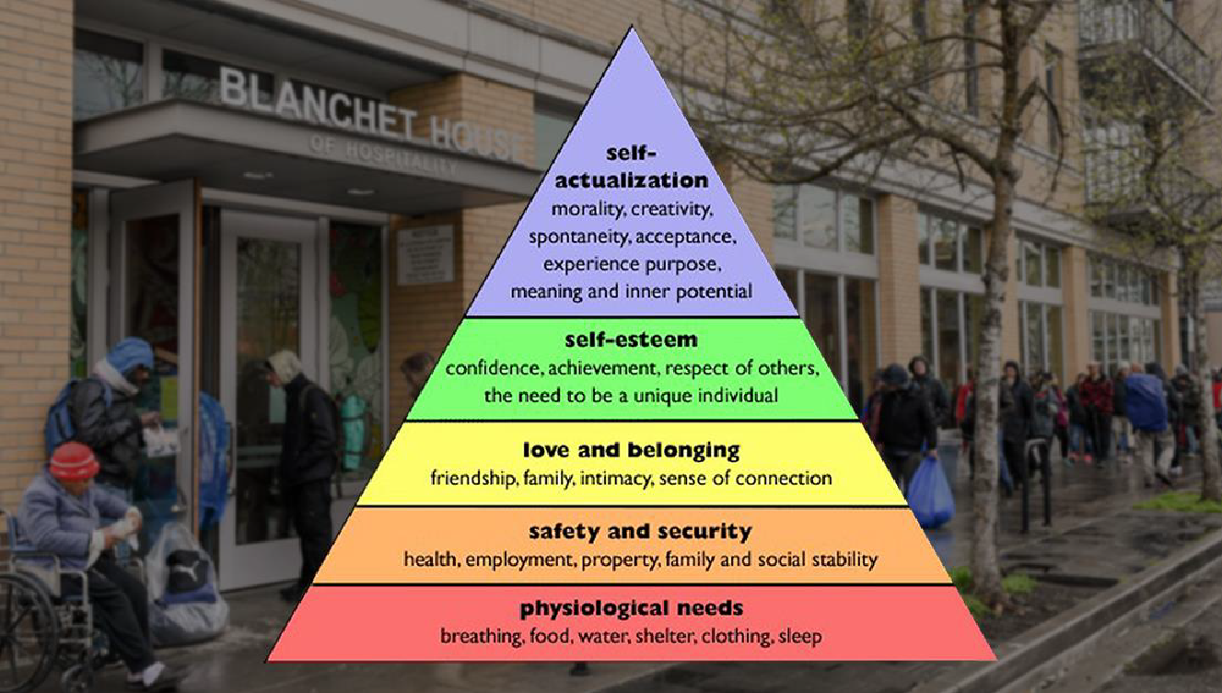
The most successful transitions occur with a warm, hand-off. Our clients are familiar with a system that shuffles them from place to place where they often engage with different people in different programs that have never met them and the process of building trust begins fresh over and over again. In the most simple and general terms, this process can be draining and overwhelming. Often people get lost in between connections. It is important that our clients understand they are not being cast off or shuffled around. The best way to do this and impart the trust gained from one place to the next is to meet the Participant in a space they find comfortable with the referring party present. Then, rather than a sense of being shuffled around, they can develop a sense of community from one agency to the next or one team member to the next.
Note: When referring to another agency, this is an opportunity to advocate for a client as well as demonstrate to an individual how they can advocate for themselves in the future.
If a situation occurs where a warm hand-off is not possible, be prepared to spend some time with the individual allowing them to lead the conversation and speak freely about their concerns and goals and whatever they happen to be feeling at the moment, even if it happens to be anger and frustration. Creating a safe space will go a long way to enriching the connection and building trust. Further, allow the client room to ask for space and don’t talk when they do not feel like engaging. Sometimes people do not know how to say they are uncomfortable with a space or situation. Being able to read verbal and nonverbal cues is important. For instance, if someone appears withdrawn, give them room.

Light Touch Case Management
Light Touch Case Management offers follow-up support and services incidentally, in small amounts and short increments. This can be utilized for individuals who are higher functioning and independent who are in the Maintenance stage of change.
Clients receiving Light-Touch have demonstrated an ability to problem-solve with little assistance, largely manage their own transportation, save for an occasional emergency, and access services with only a minimal amount of assistance, advocacy, and support. They will likely be individuals who develop their own goals and reach out to their Case Manager as needed to re-affirm goals and problem-solve when a crisis arrives.
Light-Touch is also an effective support for individuals in Pre-contemplation and Contemplation and in building a relationship to motivate change. In this way, Light-Touch can build a foundation that will help transition an individual into Intensive Case Management.

Intensive Case Management
Intensive Case Management (ICM) is marked by smaller caseloads (20-25), offers services in larger increments over time following the Progressive Engagement model. ICM should be well-resourced and utilize an array of service approaches and strategies. A provider of ICM may be more aggressive in maintaining contact and engaging with Participants incorporating an outreach approach to engage or re-engage participants.
ICM can be a relationship with an indefinite term depending on client needs and goals. An Intensive Case Manager works very closely with a client and their service network to support them in achieving and maintaining change. ICM is most effective when targeting appropriate individuals, mainly those in Contemplation or Action stages. Appropriate individuals are those with a Mental Health and/or Substance Use Disorder component and who have a history of engagement with law enforcement or at high risk of future engagement with law enforcement.
ICM uses a team approach with soliciting other Change Agents and their expertise when necessary but also bringing in a host of services to build a community around the Participant in support of their goals from Behavioral Health to Housing.

Approaching Campsites
What follows has been put together from over 10 years of experience in the field:
Rule of thumb, we always approach a camp as if visiting someone's home unannounced. In other words knock. Since these are camp sites that may be made of tents, lean-tos, or even just a broken down cardboard box in a clearing, homes may look different than what many of us are used to seeing. So, as we get close we verbally knock either by saying, literally, "knock knock" or calling out a friendly greeting like, "Good morning!" or "Good afternoon!" or "Hello!"
Before asking any questions, we introduce ourselves, who we are with and our purpose there. A typical greeting can sound like this, "Knock knock! It's Kelly and Michael with LEAD. Is anyone home? We are here to talk about services.
Even if we do not see anyone at a tent site, if the tent is closed, we assume it is occupied and respond as such. We may say whatever information we have to pass along and leave a packet of information behind with a contact card and something useful.
Sometimes, if I have no other choice but to walk through the site, I talk as I am walking, “Excuse me, I have to walk through your site, I am stepping by your front door,” or something similar. I keep resource packets simple with impact to the environment in mind, leaving as little in the pack that would create litter or harm the environment.
A card for contact info and a couple of useful items (i.e. pair of socks, granola bar, bus ticket). Sometimes, a rolled up pair of socks with my card stuck inside.
If folks are in an area that is scheduled for clearing or to be noted for trespass, we let them know and offer to connect to any assistance they need. This may include coming back with garbage bags and gloves and helping them pack and remove any garbage for them. We do not make promises.
Folks who are camping have often been moved from location to location and each time they are asked to leave their space (sometimes in not so friendly ways) it creates crises and trauma.
If someone is upset about my intrusion into their lives, we keep away from phrases like, "I am just trying to help you." Instead we acknowledge the frustration or need for autonomy or fear for their safety and ask, "How can I support you?"
Many times, if people have disengaged from services, it can often be because they have lost trust in the process. Either because they have fallen through the cracks, there is funding but no housing to match with the funding, they are on years long waitlists, shelters are difficult, the process to accessing treatment is cumbersome, and if one does not have a working phone access is nigh impossible, or people are simply not ready
If we see someone standing alone, we never ask if they are homeless. That term comes with a lot of stigma, besides, what does a homeless person look like? How far do we go describing that until we come up against stereotypes? If we see someone standing alone or with others in an area where there may be camps, we ask something along the lines of, "Are you sleeping outside?"
If we have to walk through a camp to get to another, whether it appears occupied or not, especially if there is a closed tent, we announce ourselves and apologize. We do not take anything from any sites. Bringing bottles of water in the summer is always a good thing.
Camps that are occupied will have signs such as: open food containers, fresh footsteps, hanging clothes. Abandoned camps will have: leaf litter, tent flaps open with water and debris inside, scattered food containers, foot paths are overgrown. Sometimes it may take a couple of visits to tell if a site is abandoned.
Precautions: Watch out for the bathroom. Signs include: strips of toilet paper, pages from a book, or pieces of a paper bag, and sometimes a bucket.

Safety

Safety Level System
Level One
- Meet alone with client
- Transport client in vehicle
- Visit at encampment or residence
Level Two
- Meet with client in public places with others around
- Do not visit client at encampment or residence
- Do not transport client
Level Three
- Do not meet alone with client: meet with client and another case manager present at all times
- Do not transport client
Level Four
- Do not meet with client unless with a police officer
“Your safety is paramount. Safety first, always.
In the case that a client has become aggressive or potentially dangerous for some reason, it will be staffed with the team whether or not a client should be exited, or at the very least, engaged with in a safe manner such as meeting with a second person, or in a public setting.
If at all possible, debriefing with clients consequences of aggressive and potentially violent behavior is important. Just as much as we support individuals in crisis, we support their growth through it and change that allows them to maintain their freedom and engage with their environment in a way that is also safe for them.
Any concerns of aggressive and dangerous behavior should be discussed with your supervisor who may direct the information to the rest of the team and recommend it for staffing. A verbal description of the incident will be reported first to the supervisor, followed by a written form to be filled out by the case manager and forwarded to the supervisor.
Keep an eye on where you put your hands and feet to avoid sharp objects, broken glass etc. People can be targeted for violence, tents have been slashed, people have been attacked, might want to be respectful of their wishes. They may not want to talk at first. When possible go in pairs. It isn’t intimidating and it’s safe. Waterproof hiking boots recommended. Bring gloves. Respect privacy, don’t post locations of tents and photos publicly online. Most of all, no two tent sites look alike. Just like there is no cookie cutter for a person experiencing homelessness.”

Transporting Clients
ERC staff should acknowledge particular safety concerns when transporting clients:
“When transporting clients is an expectation of the job, employers should ensure that policies and practices are in place to protect both staff and clients. At the time of pick up, the staff member should assess:
- the client’s level of agitation (if any), use of intoxicants, and the meaning of the appointment to the client
- the possibility that the client has a weapon
- their own perception of a safety risk.
ERC staff should also assess the condition of the vehicle:
- Is the interior of the vehicle free from potential weapons (ex: pens, pencils, magazines, books, handheld devices, hot beverages)?
- Is the vehicle in good working condition (ex: ample gas, working brakes, headlights/tail lights)?
- Is the vehicle equipped with proper safety equipment in case of an emergency (ex: flares, battery cables, spare tire)?
If the client is assessed to be unsafe to transport, or the vehicle is assessed to be unsafe to operate, agency policies should prohibit staff from transporting the client.”

Progressive Engagement
Progressive Engagement in Case Management As defined by leaders in ending Homelessness:
Homeless service systems have always faced enormous challenges to do more with less. Simply put, there have never been enough resources to meet demand. This has forced tough decisions about how to prioritize services and determine who needs what – and when. There is often no easy answer, but identifying strategies to maximize these resources is a good first step. And with so many more dedicated homelessness resources as a result of emergency relief legislation, it is more important than ever that we use them in the most efficient and effective way possible to end homelessness for as many people as possible. This is where a progressive engagement approach comes in.
Progressive engagement is a person-centered approach to ending someone’s homelessness. It is based on tailoring assistance to each individual or household’s needs and assessing what works best for them, with their specific strengths, and in their specific situation.
Progressive engagement starts small by helping people with their immediate needs, in order to stay housed. Consider the following example: a young woman has been living with her cousin but not paying for any of the food. The cousin becomes frustrated because she can no longer afford the grocery bill, and asks her to leave. The young woman then finds herself at intake at a homelessness shelter.
Rather than immediately putting the young woman on a wait list for housing, the provider starts their interaction with a problem solving conversation. During the discussion, it becomes clear that the young woman qualifies for SNAP assistance (formerly known as “food stamps”), but is not receiving it. Knowing that this assistance will allow the young woman to contribute to her cousin’s monthly food costs, the provider has found a quick and relatively low-cost solution to the woman’s housing crisis.
Progressive engagement can be used for any population at any level in the homelessness system. The strategy can be applied to individuals, families, people experiencing chronic homelessness, veterans, youth, and survivors of domestic violence. It also includes people who are newly homeless, and people in programs like Rapid Re-housing (RRH) and Permanent Supportive Housing (PSH) who are transitioning into their own housing.
Starting – and Maintaining – the Conversation
Progressive engagement is intended to take place throughout a person or family’s journey from homelessness to housing. The problem-solving conversation starts at the first interaction with the homelessness system, whether that takes place during street outreach, shelter intake, or a coordinated entry access point. From there, a progressive engagement approach requires the provider to communicate closely and consistently with a household.
During these interactions, the provider is seeking to identify the household’s strengths, supports, barriers, and obstacles: What kind of progress are they making? What setbacks have they experienced? And what’s changed in their journey that might impact their level of need at this time? For example, has someone in the household gotten a new job with significantly more income? Or, conversely, has someone who was doing just fine without rental assistance experienced an employment setback that requires additional funding now?
Based on these ongoing problem-solving discussions, the provider can better determine whether the household’s existing supports are working, and collaboratively work to flex supports up or down as needed until the household’s housing crisis is resolved.
Whereas other approaches may be guided by a sense that providers can “predict” what kind of intervention a household needs or by a desire to end a household’s poverty, progressive engagement meets each individual or household where they are and is focused on housing.
Progressive engagement assesses a household’s unique strengths and circumstances to determine the lightest-touch interventions required to resolve their immediate housing crisis.

Pocket Guide for Motivational Interviewing
Review the Pocket Guide for Motivational Interviewing here.
The first is a multi-page guide. It is an excellent tool to print and take with you. It contains the concepts and practices that are key to Motivational Interviewing. It is meant as a set of tools to help guide conversations of change with your clients and helps keep the focus on participant motivation and goals rather than Case Manager’s goals, however well-meant.
The second is a clinician’s guide which has condensed the information to a single page of concepts and helpful hints. This is not exhaustive and only contains the base functions of what Motivational Interviewing, but may be a useful reminder when you are more familiar with the subject.
I attest that I have read the ERC Outreach and Safety Manual:

Employee Signature and Date

Supervisor Signature and Date

Revised January 30, 2023 JM

Notes from Viola Ware, Case Worker.
From National Association of Social Workers, Code of Ethics.

